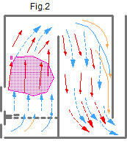
What is the furnace Igor Kuznetsov, abbreviated?

For thousands of years “forced gas movement” was used in furnaces, refer to fig.2. In those types of furnaces, movement of gases is due to thrust through the chimney. The main characteristic of these furnaces is that gases at different temperatures are not separated while inside the furnace; there is a mixture of hot and ballast gases inside the furnace and convective system. Carriers of warmth, CO2 and H2O, are released via the chimney. In this case, the burning of fuel and preservation of warmth are less efficient. Furnaces using the “forced gas movement” system are characterized by the inferior capture and usage of energy.
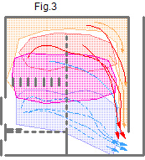
The “Free gas movement” furnace system by Igor Kuznetsov is shown in Fig.3. Inside the furnace there is a vertical slit, 2-3 cm wide, called “dry seam”. During the burning reaction in this type of furnace gases separate based on temperature levels. Carriers of warmth, CO2 and H2O, are not released via the chimney, in comparison to the “forced gas movement” system. They go up into the cap and release their heat there. Ballast gases are released through the “dry seam” without cooling down the cap.
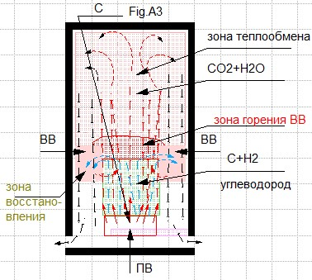
The cooled down CO2 and H2O descend down the sides of the cap, see Fig.A3. Fig.A3 shows the cap and the heating source at the bottom – C. During burning, the movement of the starting hydrocarbon materials (C+H2) takes place in the center of the heat source. The movement of the cooled gases CO2 and H2O, as well as the ballast gases, descends down along the sides where the temperature is lower. Where these gases moving in opposite direction meet, turbulence occurs. In this case, as opposed to the “forced gas movement” system, all necessary conditions and materials are available to create a restorative and oxidative chemical reaction: mixing carbon (С) with oxygen (О₂), water gas (Н₂О), carbon dioxide (СО₂). With the appearance of the following gases:
Air gas, С+О₂=СО₂; 2С+О₂=2СО;
Water gas, С+Н₂О=СО+Н₂+2802 кcаl/nм³, С+2Н₂О=СО₂+2Н₂+1714 кcal/nм³; This does not require energy to create water steam, since the water steam is the result of a burning reaction.

At the same time, there is a restorative reaction. Carbon dioxide combined with carbon hydrocarbon heated by fuel leads to carbon monoxide С+СО₂=2СО (D.B. Ginsburg), which is released along with heat, СО+1/2О₂=СО2+3018 кcal/nм3 СО. The processes of reduction and oxidation (combustion) pass continuously with the release of additional heat.
The furnace testing resulted in a direct efficiency balance of 117.2 %. This testing was conducted on June 12, 2018 in Murzinka (Sverdlovsk oblast, Russia) by the “Nuclear and renewable energy station” chair of the Ural Federal University named after the first President of Russia Boris Yeltsin, Mira Street 19, Ekaterinburg, Russia 620002. Email: s.e.shcheklein@urfu.ru. Tel.: +7(343)375-95-08.
More here , -http://eng.stove.ru/stati/sistemyi_byitovyih_pechey_ih_priznaki_i_razlichiya

Igor Kuznetsov, 19.08. 2018

